American University of Sharjah  School of Engineering  Department of Computer Engineering  P. O. Box 26666  Sharjah, UAE  Name: ____________________  ID : ____________________ |  | Instructor: Imran A. Zualkernan  Office: ESB-2066  Phone: 971-6-515 2953  Fax: 971-6-515 2979  e-mail: izualkernan@aus.edu  Semester: Fall 2020

COE457 – Mid Term Exam

Fall 2020

Total Time: 1 hour and 30 minutes

/100

The quiz open book and notes. Attempt both questions.

Please note that questions have been designed so that it is not possible for two students to come up with code that is structurally similar. Two solutions where the names of the variables have been changed or similar cosmetic changes done will be considered a violation of AUS academic integrity code and will result in an automatic F in the course for BOTH parties.

Please do not upload any Zipped or similar files. Only THIS Word file appropriately filled out and PRIVATE access to your code and website on GIT where required.

Q1. (50 points) Modify the existing Bootstrap code discussed in the class (and shown below) using jQuery ONLY so that the Flip button in the navigation menu exchanges the description of the two poets upon clicking. For example, when the Flip is pressed, Basho moves to the right and Yosa to the left. When pressed again, Basho moves to left and Yosa to the right.

If you make extensive changes to Bootstrap code (i.e., replace Bootstrap with other code) or dont use jQuery exclusively, then you are limiting yourself to a maximum grade of 30%.

Program Expected Output:
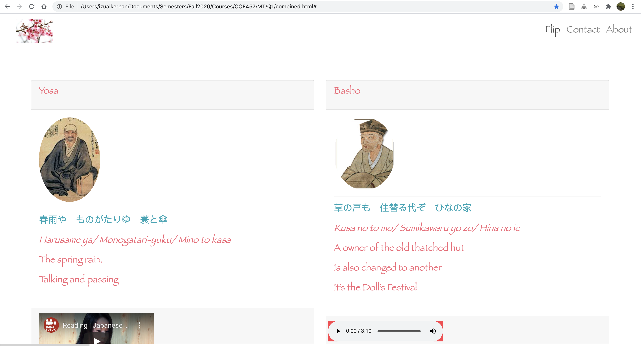

After Flip is pressed.

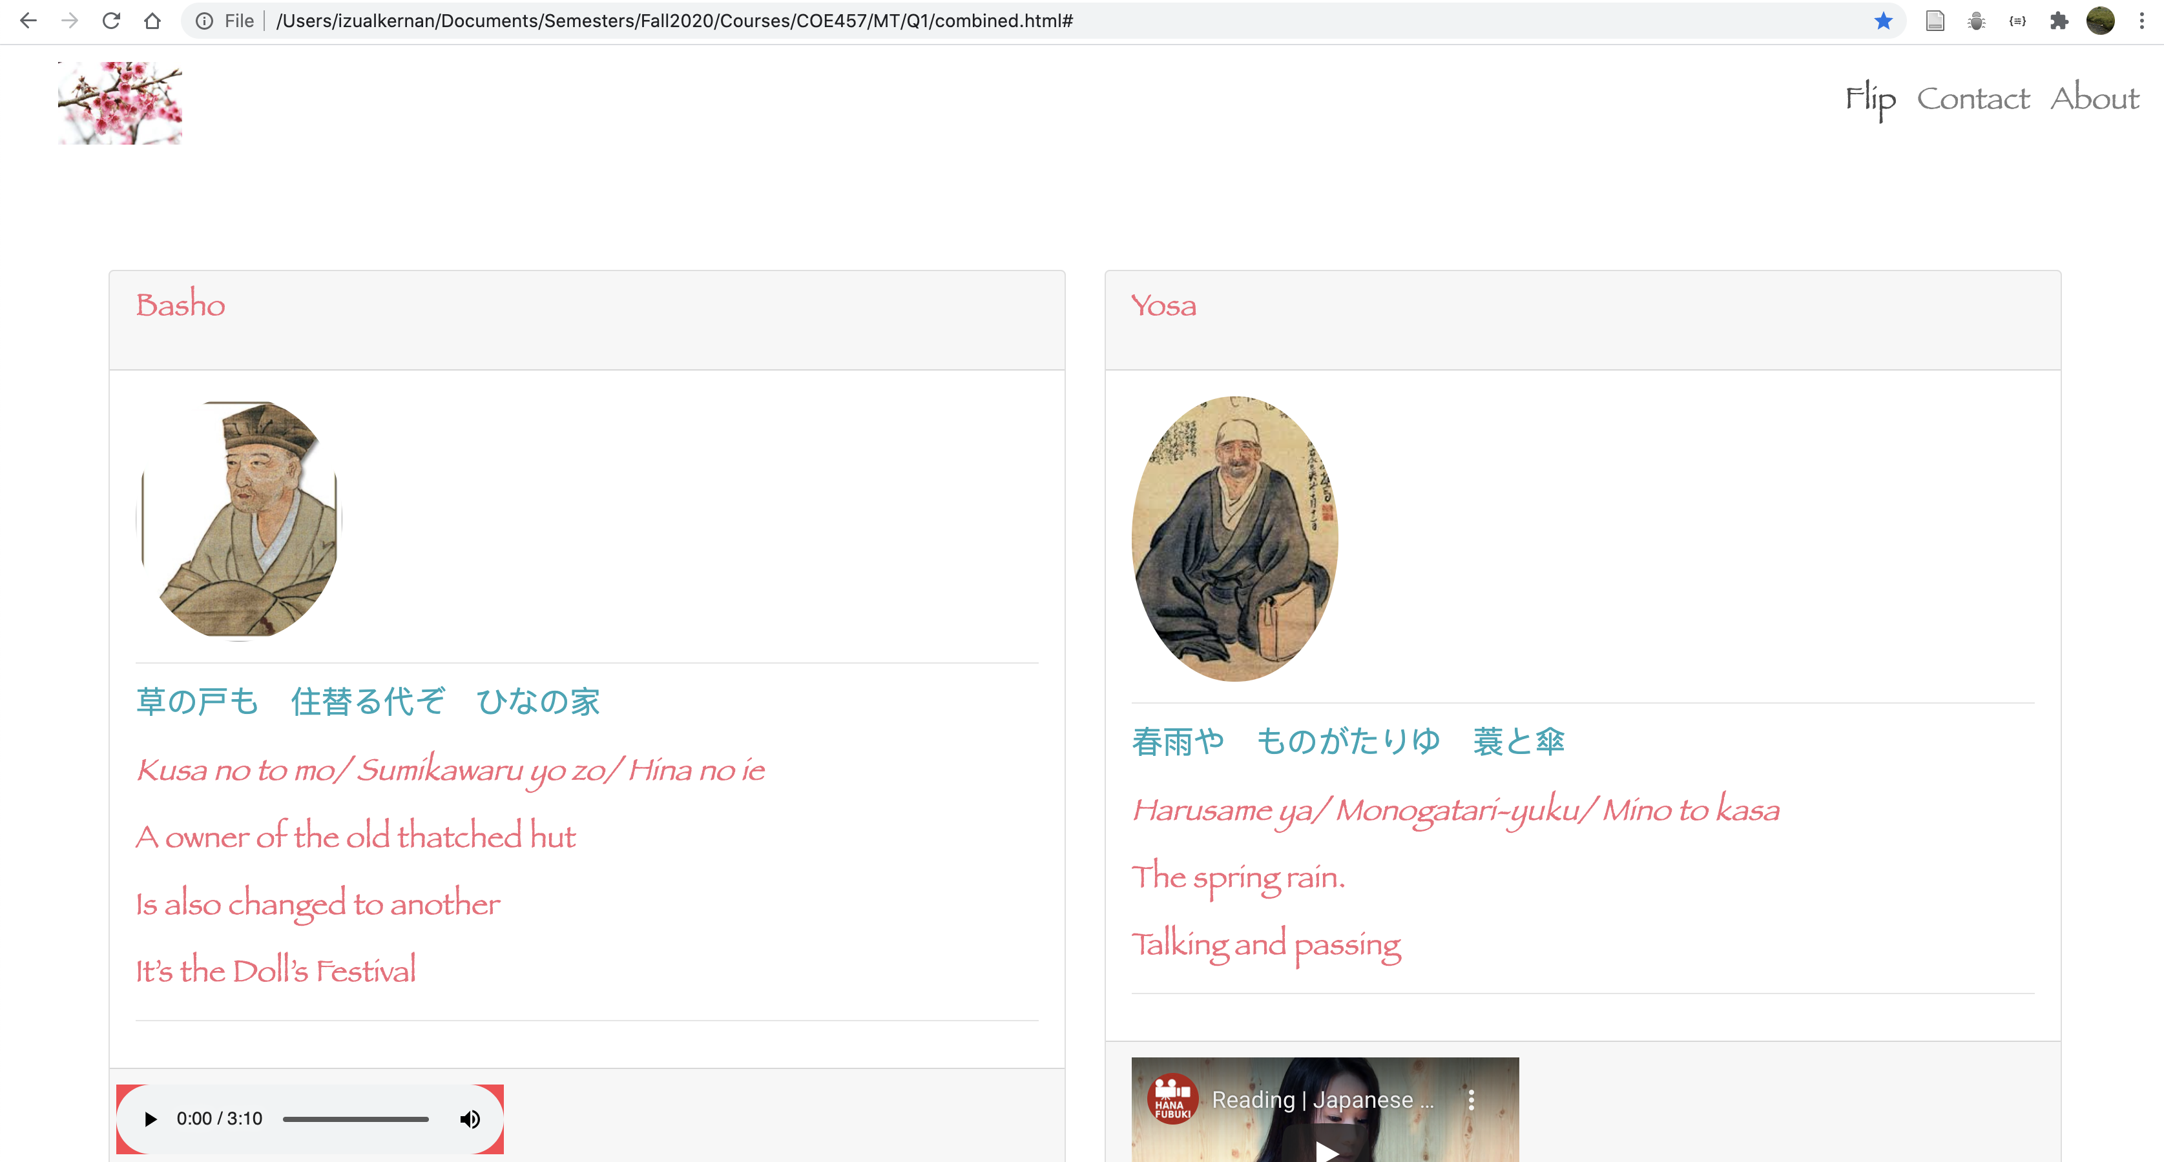

Grading Rubric:

0-3 | 4-6 | 7-8 | 9-10
- Bootstrap code has been changed extensively and unnecessarily.  - jQuery is not used. | - No significant changes have been made to the Bootstrap code  - jQuery is used only but only pieces of solution are working.  - For example, Flip button when pressed does something.  - The structure of the cards changes somehow but not correctly. | - No significant changes have been made to the Bootstrap code.  - The Flip almost works but not entirely.  - jQuery is used only. | - No significant changes have been made to the Bootstrap code.  - The Flip works correctly every time and forever.  - jQuery is used only.

Solution:

Explanation of the solution strategy (10 points):

In English explain how you solved the problem.

Key changes made to the code (30 points):

Show only the lines of code you changed in the original files with comments on what the changes mean. DO NOT PASTE THE WHOLE CODE HERE. Put a brief comment in front of each code segment to explain how it contributed to your overall solution.

Link to a private github website showing the code working (10 points):

Upload the website on github and make it privately available so it can be tested remotely. Please add izualkernanaus as a collaborator to ONLY provide me access to your website. YOU MUST NOT MAKE YOUR GIT REPOSITORY PUBLIC.

Go to Settings of your newly created PRIVATE Git and hit Manage Access and Invite a Collaborator.

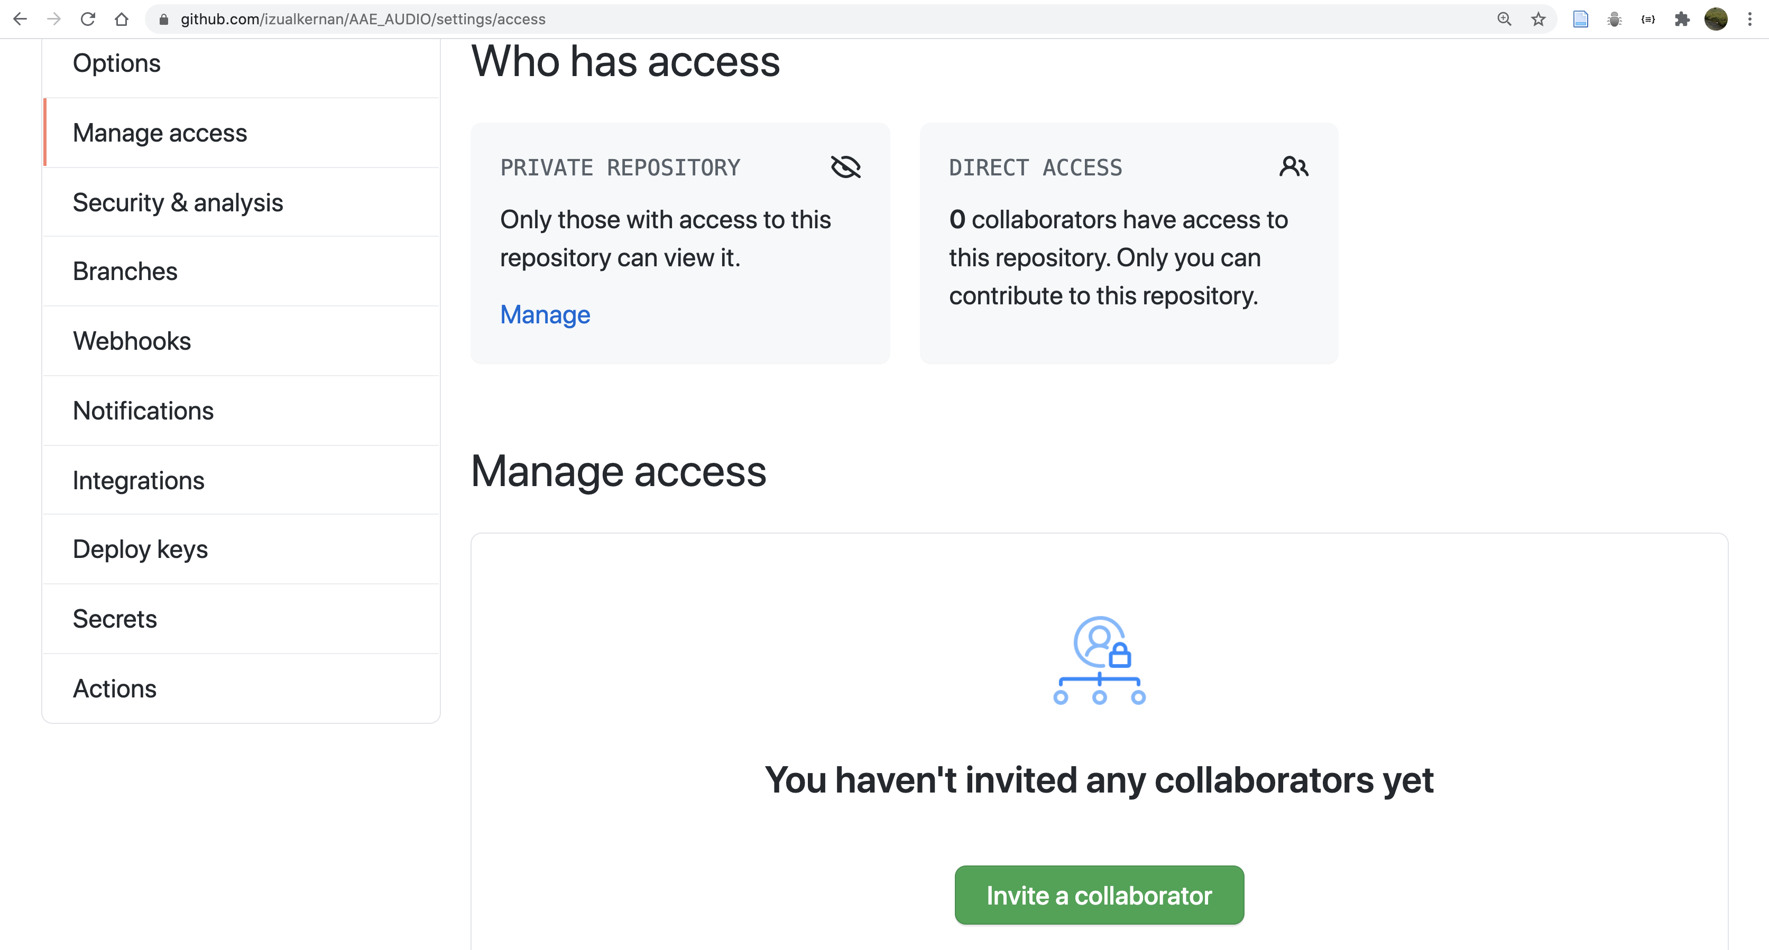

Enter izualkernanaus as the name of the collaborator and you will see the following.

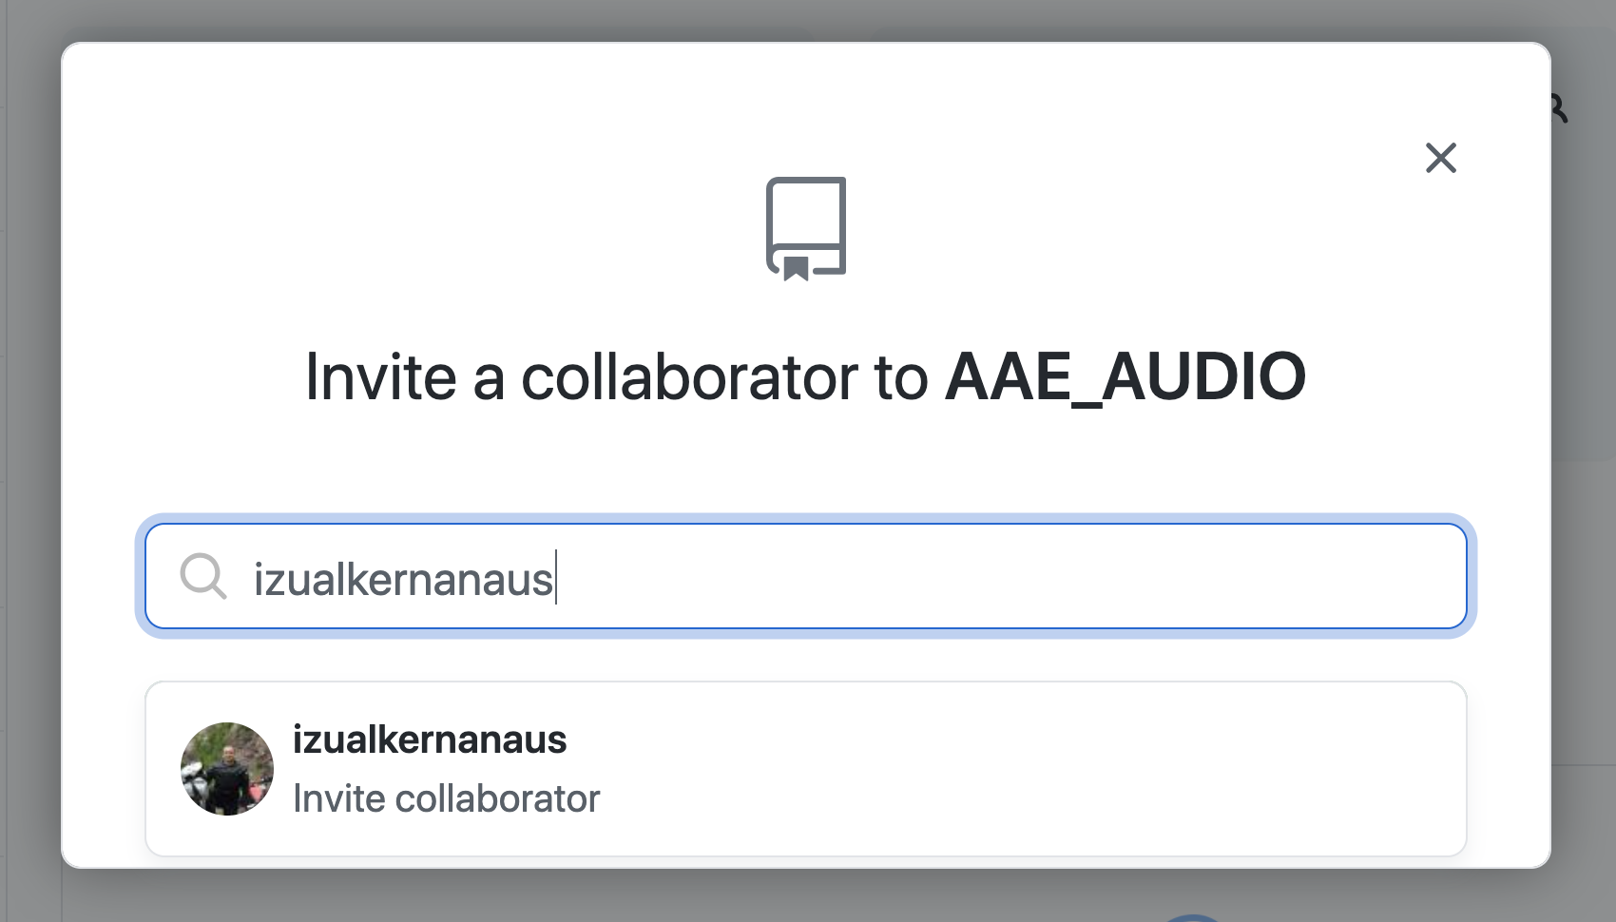

If successful, you should see the following dialog box.

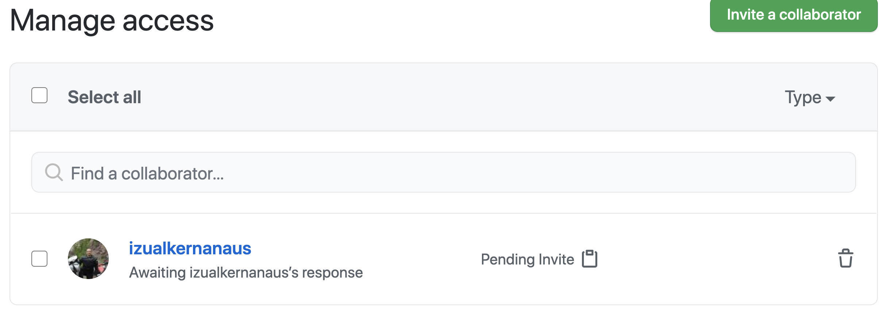

Screenshot (Paste your code screenshot here):

Leaving this space empty will result in automatic deduction of 10 points.

Q1. (50 points) Write a server based on sockets using Node.js that shows the idle% of all the CPU cores on your computer through a browser. The output should look exactly like shown below. You are free to choose a color scheme, but the output should look like the one shown including margins, alignment etc.

Note that your computer may have different number of cores so the number of cores in your output may be different.

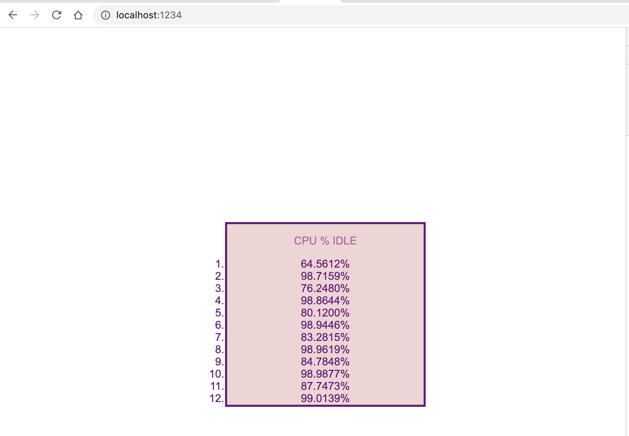

Hint: Consider the os library already included with Node.js.

Grading Rubric:

0-3 | 4-6 | 7-8 | 9-10
- A library other than sockets is being used or an HTTP library is being used. OR  - The browser is frozen and does not show anything. OR  - No screenshot is provided. | - Only sockets are used for communication on server side. AND  - The browser shows some output, but the output is not correct. | - Only sockets are used for communication on server side. AND  - The browser shows some correct output.AND  - The output is mostly correct but not formatted exactly as shown. | - Only sockets are used for communication on server side. AND  - The output is formatted exactly as shown in the expected output including colors, font types, buttons, etc.

Solution (Past your code here):

Server code:

Front-end Code:

Screenshot (Paste your screenshot here)
Leaving this space empty will result in automatic deduction of 10 points.

